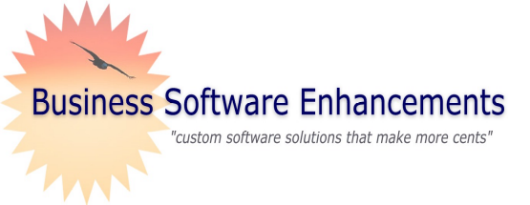

Thank you for taking the time to
Business Software Enhancements
P.O. Box 1480
Amherst, NY 14226

A message from

the president….
learn more about Business

Teaming Together

for System Integration

Software Enhancements. We have been
in business in Western New York
since 1991. Our expertise and
on-hands assistance will certainly
make a difference in your company’s
productivity.


Call us today at 716-432-4306
to see how we can make your
business grow.

Kindest regards,

Paul Sortino, President



Phone: 716-432-4306
Web site: good-namerica.com



MAS 90 Training and Support Services

Software Integration

Delphi Programming

- Crystal Report Training Sessions In-House

Business Basic Customization

Business Software Enhancements “Strong

Accounting Software”

Integration of Data Within Various Software Packages

“Stand-alone Quote System Software Program,” Created by Business Software Enhancements

Our Objectives:

For more information, please check below:
- MAS 90 Training and Support Services

- Software Integration

- Delphi Programming

- Crystal Report Training Session
In –House

- Business Basic Customization

- Business Software Enhancements
Strong Accounting Software

- Integration of Data

- Stand-alone Quote System, created by
Business s Software Enhancements

Please mail to:
Business Software Enhancements
P.O. Box 1480, Amherst, NY 14226

 | Name: __________________________________
Address: ________________________________

Phone: __________________________________

Fax: __________________________________

Email: __________________________________
Phone
E-mail
Or, you can email us at:
pauls@good-namerica.com

Credit Card No. |  |  |  |  |  | Expire Date
Signature

Services/Products:

Provide our customers with a complete integrated package, which allows flawless exchanges within the systems of our customers’ software packages. Our goal is to:

Minimize tedious data entry.

Minimize duplication of data entry.



Let our team of professionals assist you.

